Santhanakrishnan Ramani

SID: 105720585

**Assignment 4**

***Part 1***

1)Markov blanket of Sneeze

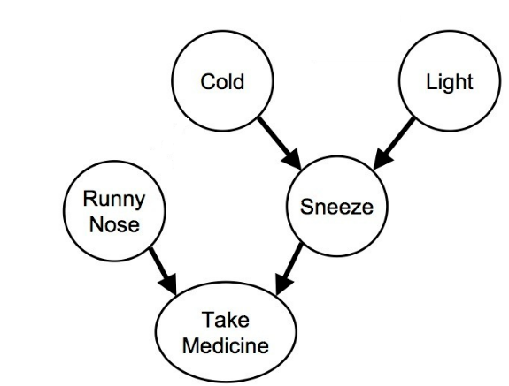

2) Markov blanket of Take Medicine

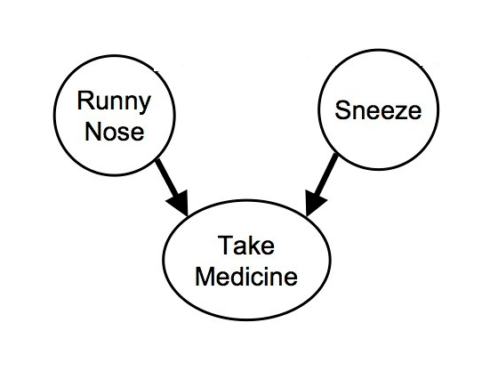

3)P(L, C, RN, S, TM) = P(L) P(C) P(RN|C) P(S|C, L) P(TM|RN, S)

4) P(C=1| TM=1, RN=0, L=0) = P(C=1, TM=1, RN=0, L=0) / P(TM=1, RN=0, L=0)

P(L=0) P(C=1) P(RN=0|C=1) P(S|C=1, L=0) P(TM=1|RN=0, S)

=> -------------------------------------------------------------------------------

P(L=0) P(C) P(RN=0|C) P(S|C, L=0) P(TM=1|RN=0, S)

0.000825

=> -------------- =  **0.2273**

0.0036

5) Markov Net

6) Joint Probability Function for the above markov net in terms of potential functions

P(L, C, RN, S, TM) = 1/Z * Ψ1(L, C, S) * Ψ2(C, S, RN) * Ψ3(RN, S, TM)

Ψ1(L, C, S) => P(L) P(C) P(S|C, L)

Ψ2(C, S, RN) => P(RN|C)

Ψ3(RN, S, TM) => P(TM|RN, S)

7) No, it isn’t a polytree, as there is more than one undirected path between nodes cold and take medicine

In order to make the given Bayes Net a polytree, any of the following links can be removed

* Sneeze – Take Medicine
* Cold – Sneeze
* Cold – Runny Nose
* Runny Nose – Take Medicine

8) (a) C ? TM | RN,S - True  
 (b) TM ? C | S - True   
 (c) C ? L  - True  
 (d) C ? L | TM - False   
 (e) RN ? L | TM - False  
 (f) RN ? L  - True  
 (g) RN ? L | S - True  
 (h) RN ? L | C, S - True

***Part 2***

1) P(P, D,H, U, A) = P(P) P(D) P(H|P) P(U|P, D) P(A|U)

2) P(H) = ∑P P(P) P(H|P) ∑D P(D) ∑U P(U|P, D) ∑A P(A|U)

3) P(U=u|D=d) = ∑P P(P) P(U=u|P, D=d)

***Part 3***

1. P(G1=2|X2=50) = P(G1=2,X2=50) / P(X2=50)

P(G1=2) ∑G2 P(X2=50|G2) P(G2|G1=2) ∑X1 P(X1|G1=2) ∑G3 P(G3|G1=2) ∑X3 P(X3|G3)

= --------------------------------------------------------------------------------------------------------------

∑G2 P(X2=50|G2) ∑G1 P(G1) P(G2|G1) ∑X1 P(X1|G1) ∑G3 P(G3|G1) ∑X3 P(X3|G3)

= 0.0067 / 0.127 = 0.05275

1. P(X3=50|X2=50) = P(X3=50,X2=50) / P(X2=50)

∑G2 P(X2=50|G2) ∑G1 P(G1) P(G2|G1) ∑X1 P(X1|G1) ∑G3 P(X3=50|G3) P(G3|G1)

= --------------------------------------------------------------------------------------------------------------

∑G2 P(X2=50|G2) ∑G1 P(G1) P(G2|G1) ∑X1 P(X1|G1) ∑G3 P(G3|G1) ∑X3 P(X3|G3)

= 0.0065/ 0.127 = 0.0513